
WILDFLY APPLICATION
Server Setup

Key Contacts

Venkatesh Balaji,
Enterprise Architecture
Solverminds Solutions and Technologies Pvt Ltd
vbalaji@solverminds.com

Table of Content

1. Introduction 3
2. Deployment Architecture 3
3. Purpose 3
4. Installation 3
4.1 Pre Requisite 3
4.2 Deployment Files 4
5. Directory Structure 5
6. Memory Changes 5
7. Configuration Tasks 6
7.1 Data Source Configuration 6
7.1.1 Database Connection Validation Setting 7
7.1.2 Driver Configuration 7
7.1.3 Authentication 7
7.2 Transaction Time-out 8
7.3 Infinispan Cache 8
7.4 Socket Configuration 9
7.4.1 HTTP Port 9
7.5 AJP Configuration 9
7.5.1 Cross-origin resource sharing Configuration 9
7.6 Logger Configuration 10
7.7 Library Configuration 10
7.7.1 How to configure module.xml file 11
8. File deployment 11
9. System Properties 11
10. Start-Up 12
11. Next 12

Introduction

Wildfly, previously known as JBoss AS, is a fully implemented JEE container – application server. Wildfly is production ready, cross-platform and open-source application server Purpose. In Pulse planet Application, we are going to host Wildfly version of 10.1.0.

Deployment Architecture

Please find the below deployment Architecture of Pulse Planet.
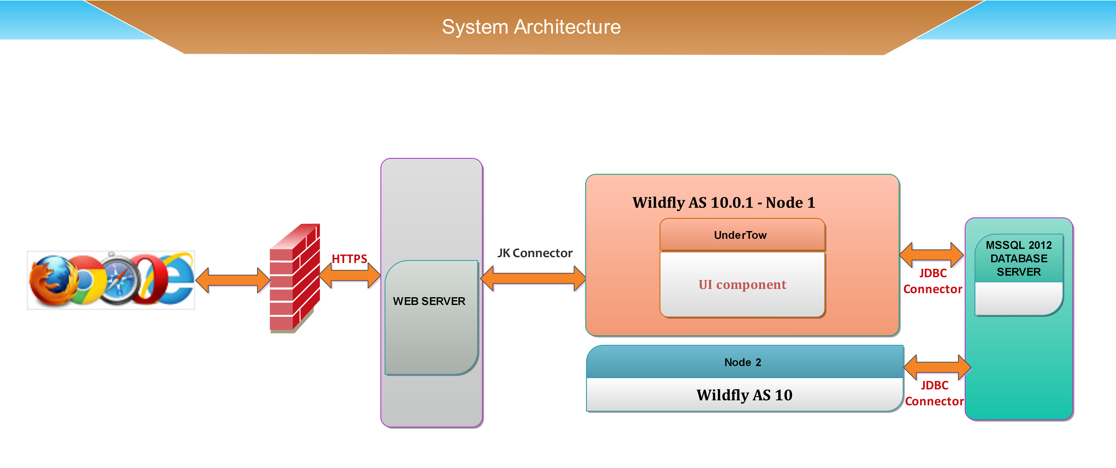

Purpose

Purpose of the document is to provide the steps to configure Wildfly Application Server.

Installation

Pre Requisite

Install | Download
Make sure to install JDK 8 update 25. | Download WildFly from the following URL and extract its to the server directory.  URL : http://WildFly.org/downloads/  Version: 10.1.0.Final with Java EE7 Full & Web Distribution

Team | Credential
DB | DB Team has to provide the Database login details such as IP,Port, Username and password of the DB to configure in Wildfly Server.

Deployment Files

Application dependent Server files and library jars will be deployed as mentioned deployment path.

File/Folder | Deployment path
Svmapp.ear | $WildFly-8.2.0.Final\standalone\deployments\\
lrp | $WildFly-8.2.0.Final\modules\\
com | $WildFly-8.2.0.Final\modules\\
svm | $WildFly-8.2.0.Final\modules\\

Directory Structure
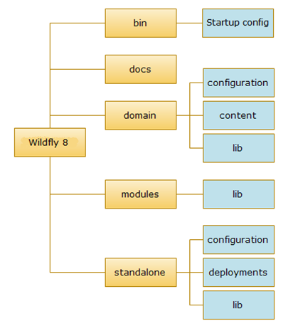

appclient | It contains Configuration files, deployment content.
bin | Start up scripts, start up configuration files
docs | XML schema definition files & Example configuration files
domain | Configuration files, deployment content
modules | Library files will be placed under the folder modules. In general we call the library as modules because of modular class loading architecture.
standalone | It contains standalone configuration files, deployment files.

Memory Changes

Configure the Minimum and Maximum heap memory.To change the memory search the text “memory allocation pool” in standalone.conf.bat.The file will be available in “$wildfly-8.2.0.Final\bin\”.In Pulse planet, currently server is allocated with the 5G of Minimum and Maximum Memory.

rem # JVM memory allocation pool parameters - modify as appropriate.
set "JAVA_OPTS=-Xms5120M -Xmx5120M -XX:MaxPermSize=256M"

Note: The Minimum and Maximum memory will be configured based on System RAM.

Configuration Tasks

Configuration such as data-source, logger, HTTP ports,global modules will be configured in a single file standalone-full.xml. The configuration will be mapped under the separate Subsystem in the same file.

The XML file will be available in the path
$WildFly-8.2.0.Final\standalone\configuration.

Data Source Configuration

Datasources are configured through the datasource Subsystem. Declaring a new datasource consists of two separate steps: ssYou would need to provide a JDBC driver and define a datasource that references the driver you installed. Search the Keywork “datasource:2.0” in standalone-full.xml.

<datasources>
<datasource jndi-name="java:jboss/datasources/ExampleDS" pool-name="c">
<connection-url>jdbc:h2:mem:test;DB_CLOSE_DELAY=-1</connection-url>
<driver>h2</driver>
<pool>
<min-pool-size>10</min-pool-size>
<max-pool-size>100</max-pool-size>
<prefill>true</prefill>
</pool>
<security>
<security-domain>EncryptedPassword</security-domain>
</security>
<timeout>
<blocking-timeout-millis>10</blocking-timeout-millis>
<idle-timeout-minutes>100</idle-timeout-minutes>
</timeout>
<statement>
<prepared-statement-cache-size>1000</prepared-statement-cache-size>
</statement>
</datasource>

*java:jboss/datasources/ExampleDS -Datasourcename
*ExampleDS -Datasourcename
*jdbc:h2:mem:test;DB_CLOSE_DELAY=-1 -jdbc:sqlserver://IP:DB-server port
*EncryptedPassword - Encrypted Password.

Database Connection Validation Setting

Enable database connection validation using the below tagging within the <datasource> section of the server configuration file

<validation>
<valid-connection-checker class-name="org.jboss.jca.adapters.jdbc.extensions.mssql.MSSQLValidConnectionChecker"/>
<check-valid-connection-sql>select 1</check-valid-connection-sql>
<validate-on-match>false</validate-on-match>
<background-validation>true</background-validation>
<background-validation-millis>10000</background-validation-millis>
</validation>

Driver Configuration

The driver name should be configured in the same subsystem data-source 2:0.Refer Section Library Path to check how to configure Libraries in Wildfly Subsystem.

<driver name="h2" module="com.microsoft.sqlserver">
<xa-datasource-class>com.microsoft.sqlserver.jdbc.SQLServer</xa-datasource-class>
</driver>

* h2-Drivername
* com.h2database.h2-Library deployed Path

Authentication

Secure the Datasource authentication using the name spacing subsystem security:1.2.
Search the text “Security” in XML file.

<security-domain name="EncryptedPassword" cache-type="default">
<authentication>
<login-module code="org.picketbox.datasource.security.SecureIdentityLoginModule" flag="required">
<module-option name="username" value="Username"/>
<module-option name="password" value="Securitypassword"/>
<module-option name="managedConnectionFactoryName" value="jboss.jca:name=ExampleDS,service=LocalTXN"/>
</login-module>
</authentication>
</security-domain>

*EncryptedPassword - Encrypted Password
*Username- Username of datasource
*Securitypassword -Encrypted Datasource Password
*ExampleDS -Name of the Datasource
*LocalTXN-Transactiontype

Transaction Time-out

Transaction time-out should be configured under the subsystem Transaction.Search the text “txn-status-manager”.Configure the time-out of 600 Seconds.

<recovery-environment socket-binding="txn-recovery-environment" status-socket-binding="txn-status-manager"/>
<coordinator-environment default-timeout="600"/>

Infinispan Cache

Below is the XML configuration for infinispan cache subsystem.Search the text “infinispan” and paste the below cache configuration at the end of tag.

<cache-container name="PPCache" default-cache="sessioncache">
<local-cache name="sessioncache">
<eviction strategy="NONE" max-entries="-1"/>
<expiration lifespan="-1" max-idle="18000000"/>
</local-cache>
</cache-container>

Socket Configuration

The HTTP and AJP port should be configured under the socket-binding-group.Please note the Port which is occupied by other application will leads to Port conflict.So use the Port which is free.

HTTP Port

By default the application is configured with Port 8080.To change, Search the text “http” and change the port as required.

<socket-binding name="http" port="{jboss.http.port:8080}"/>

AJP Configuration

Add the ajp listener and GZIP configuration tag under the subsystem Undertow:1.2.Search the text “undertow:” and paste the below ajp tagging.

<ajp-listener name="ajp" socket-binding="ajp"/>

Search the text “<filter-ref”, after that end of the tag place the below highlighted tag.

<filter-ref name="gzipFilter" predicate="exists['%{o,Content-Type}'] and regex[pattern='(?:application/javascript|text/css|text/html|text/xml|application/json)(;.*)?', value=%{o,Content-Type}, full-match=true]"/>

Search the text “<response-header”, after the end of the tag place the below highlighted tags.

<response-header name="Vary-header" header-name="Vary" header-value="Accept-Encoding"/>
<gzip name="gzipFilter"/>

Cross-origin resource sharing Configuration

In the same Undertow Subsystem, Configure the CORS header server wide in the WildFly standalone-full.xml.Search the text “alias="localhost" in XML file.Below the end of tag paste the header mentioned.

<filter-ref name="Access-Control-Allow-Origin"/>
<filter-ref name="Access-Control-Allow-Methods"/>
<filter-ref name="Access-Control-Allow-Headers"/>
<filter-ref name="Access-Control-Allow-Credentials"/>
<filter-ref name="Access-Control-Max-Age"/>

Logger Configuration

This configuration is Optional. In case if the system required additional logger configuration,then this the configuration looking for. This will be configured under the subsystem logging.Search the text “logging” and paste the below config in the required place.

<periodic-rotating-file-handler name="FILE" autoflush="true">
<formatter>
<named-formatter name="PATTERN"/>
</formatter>
<file relative-to="jboss.server.log.dir" path="sample.log"/>
<suffix value=".yyyy-MM-dd"/>
<append value="true"/>
</periodic-rotating-file-handler>

In Pulse Planet,We are going to configure additional logger of “PPBE_Logger”.

<logger category="PPBE_Logger" use-parent-handlers="false">
<level name="INFO"/>
<handlers>
<handler name="CONSOLE"/>
<handler name="PPBE_FILEHANDLER"/>
</handlers>
</logger>

*sample-Name of the log as like server.log

Library Configuration

Since WildFly is based on class loading architecture. The libraries are generally grouped as modules. The application library should be placed under $WildFly-8.2.0.Final\modules\

Step 1: Create a folder named svm under $WildFly-8.1.0.Final\modules
Step 2: Under the folder “svm”, create the folder structured as com-->lib-->main.
Step 3: Copy and paste the all lib jar along with module.xml file inside the folder main.

How to configure module.xml file

Verify that all the relavant jar are available in the folder and map if there an required dependent library jars in moduel.xml

<module xmlns="urn:jboss:module:1.3" name="svm.com.lib">
<resources>
<resource-root path="GlobalObjects.jar"/>
<resource-root path="serverutils.jar"/>
</resources>
<dependencies>
<module name="javax.api"/>
<module name="javax.transaction.api"/>
</dependencies>
</module>

svm.com.lib -Library Folder path.
GlobalObjects.jar-Jar name
javax.api-Dependent Jar names

File deployment

Application server files (.ear,.war,.jar) will be deployed in $WildFly-8.2.0.Final\standalone\deployments

System Properties

Configure Application server path in system environment variable as shown below.

Variable Name: JAVA_HOME
Variable Value: C:\Program Files\Java\jdk1.8.0_73

Variable Name: WildFly_HOME
Variable Value: D:\WildFly-8.2.0.Final

Variable Name: WildFly_DEPLOY
Variable Value: D:\WildFly-8.2.0.Final\standalone\deployments

Variable Name: WildFly_LIB
Variable Value: D:\WildFly-8.2.0.Final\modules\

Start-Up

Start the WildFly Application Server through the command as standalone -c standalone-full.xml in command prompt with Administrator Privilege.

Next

Please refer the Pulse Planet_Apache Installation document for Apache Server Set-up.

